**ALU Project**

**CS 4341.001 Fall 2020**

**Cohort: Trohoc**

Cohort Members: Rutvij Shah, Emory Blair, Khalid Dakak, Ryan Radloff, Anindita Palit

Project Description:

**Circuit Diagrams:**

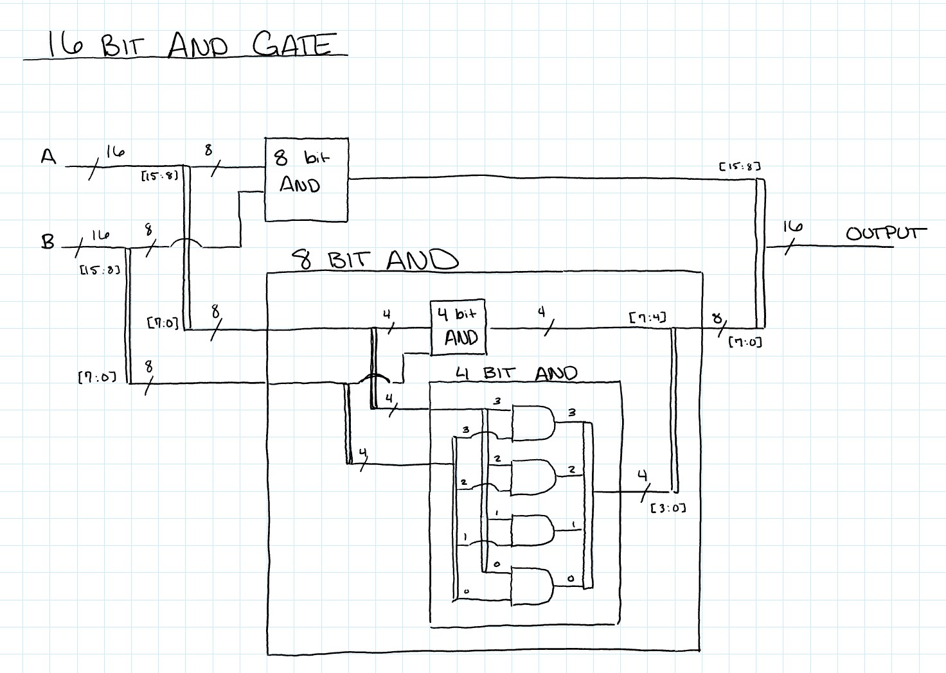

16 Bit AND Gate

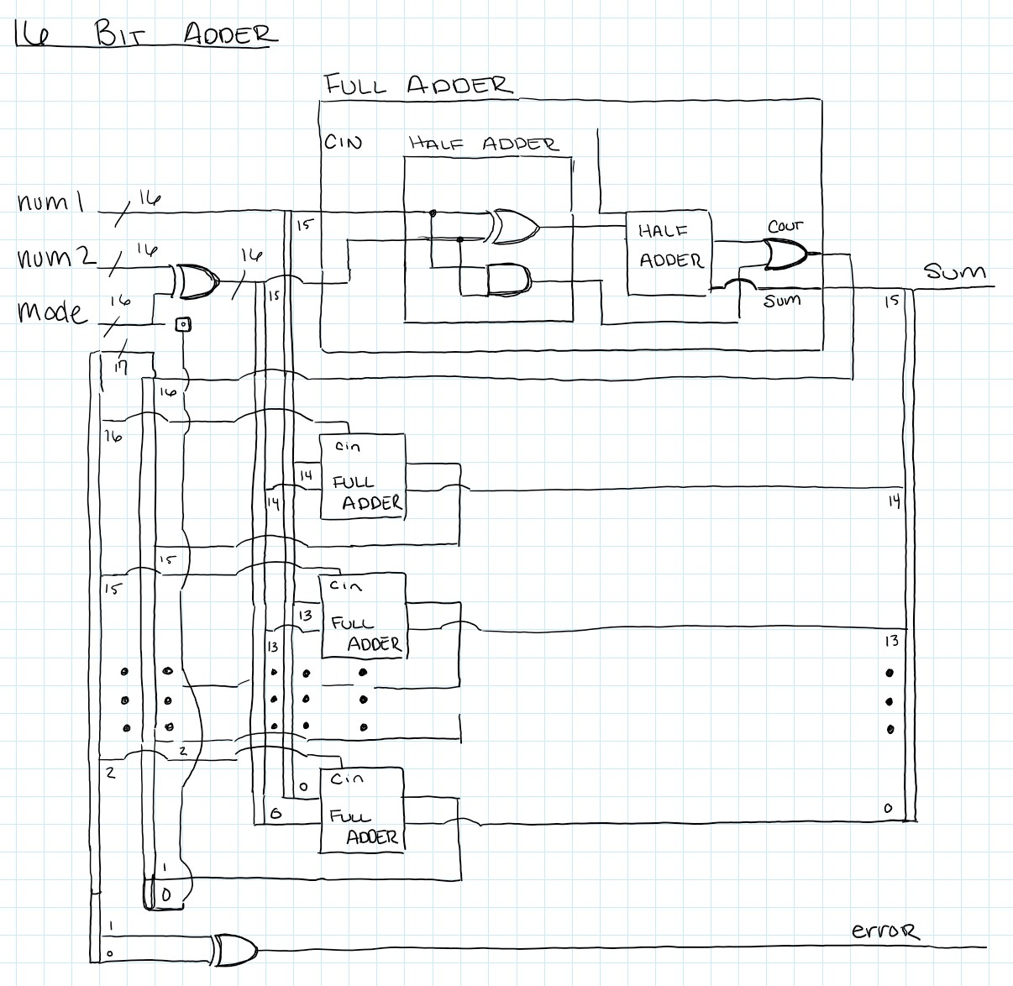

16 Bit Full Adder

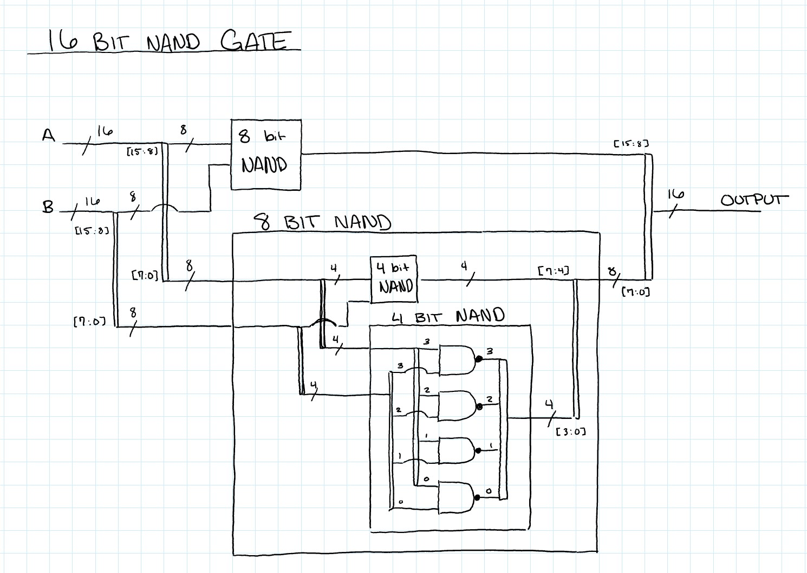

16 Bit NAND Gate

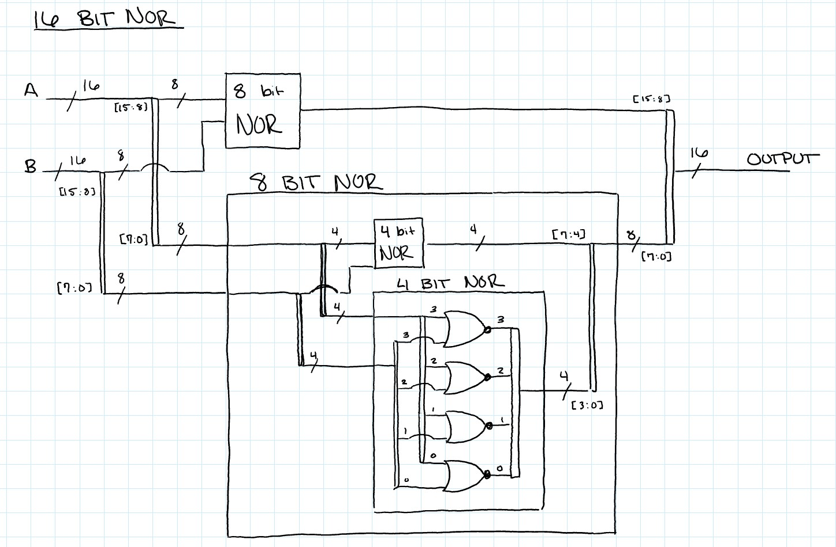

16 Bit NOR Gate

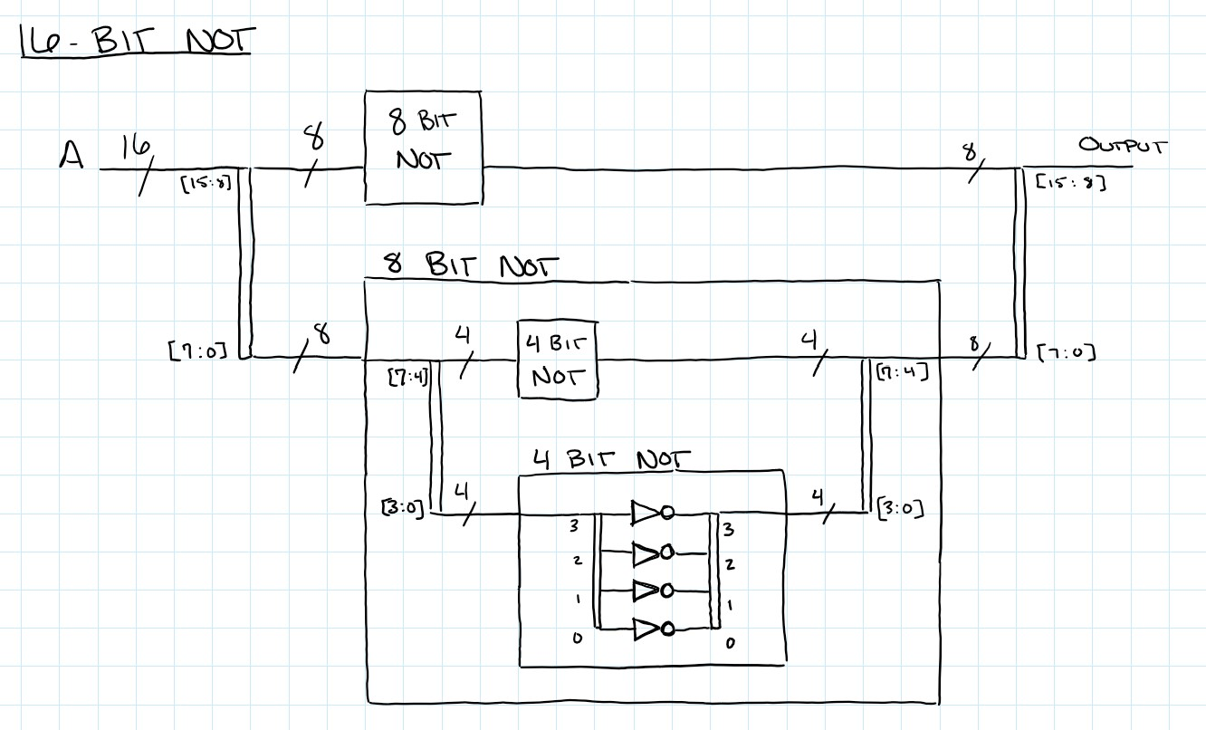

16 Bit NOT Gate

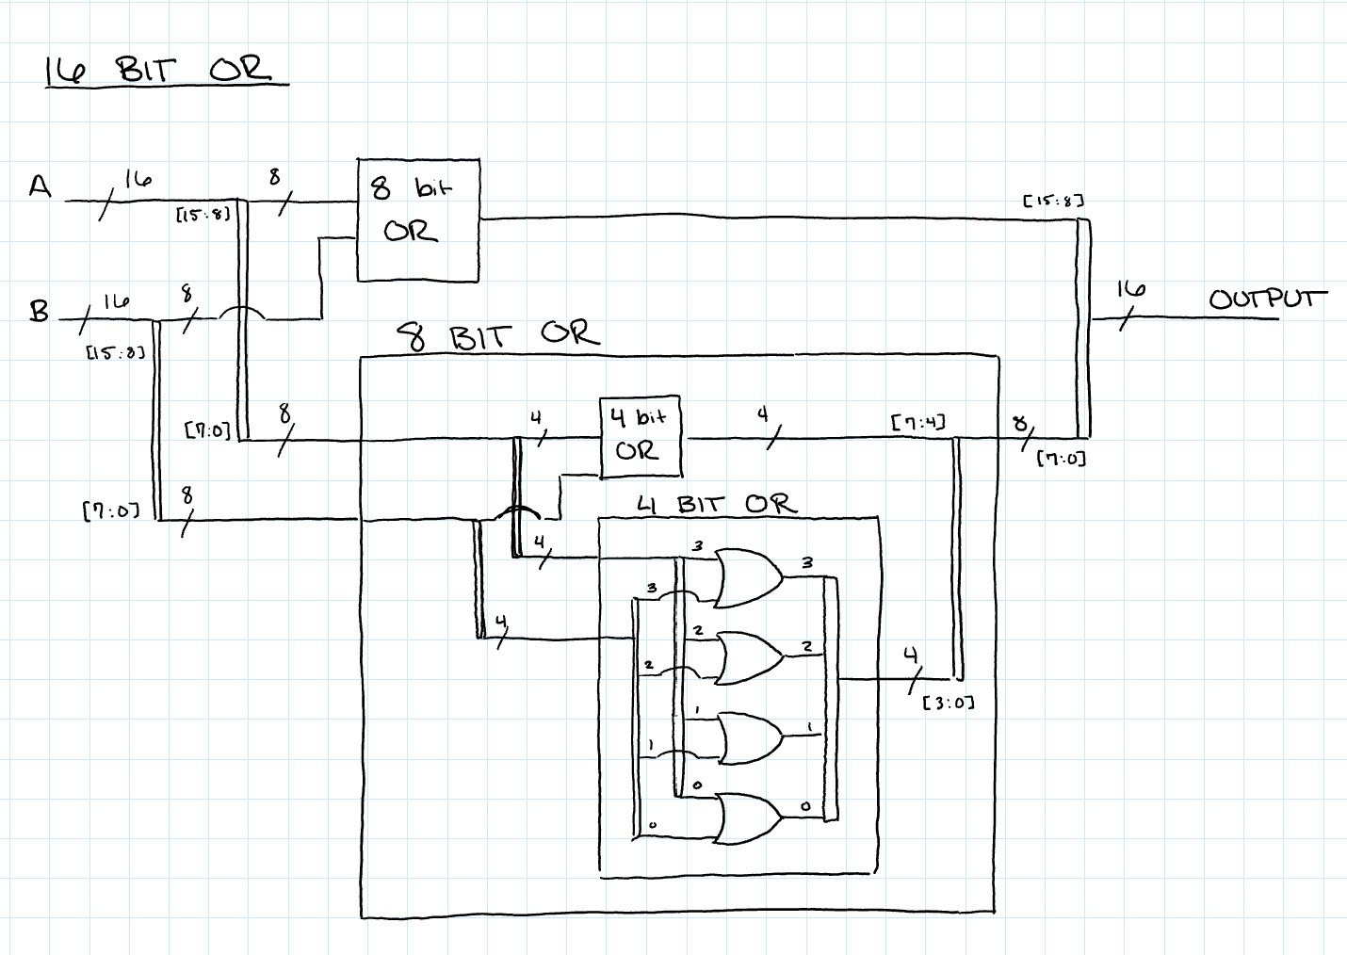

16 Bit OR Gate

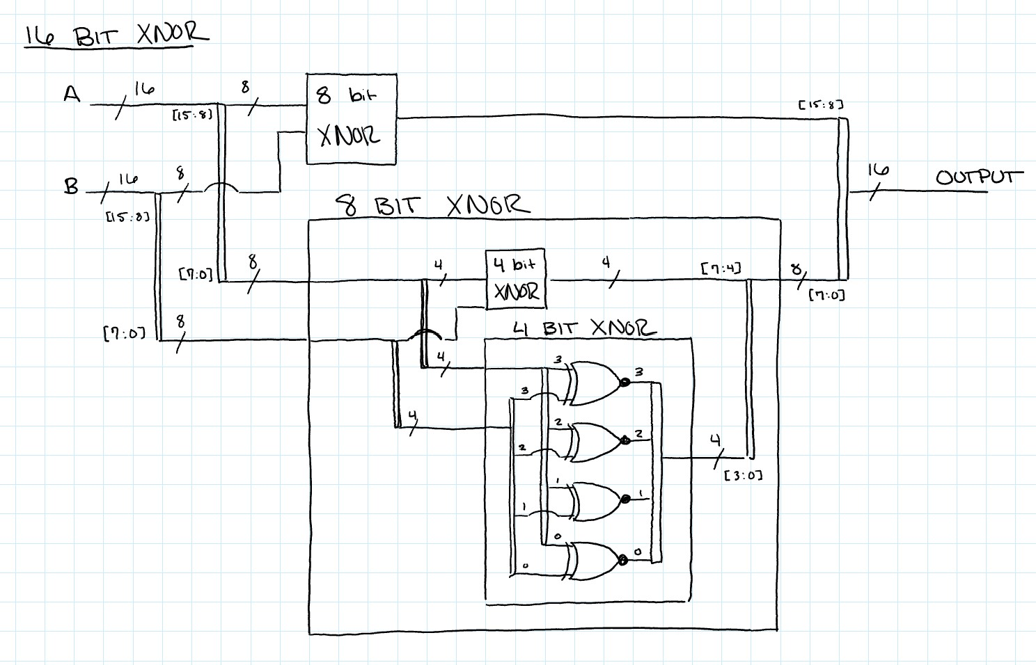

16 Bit XNOR Gate

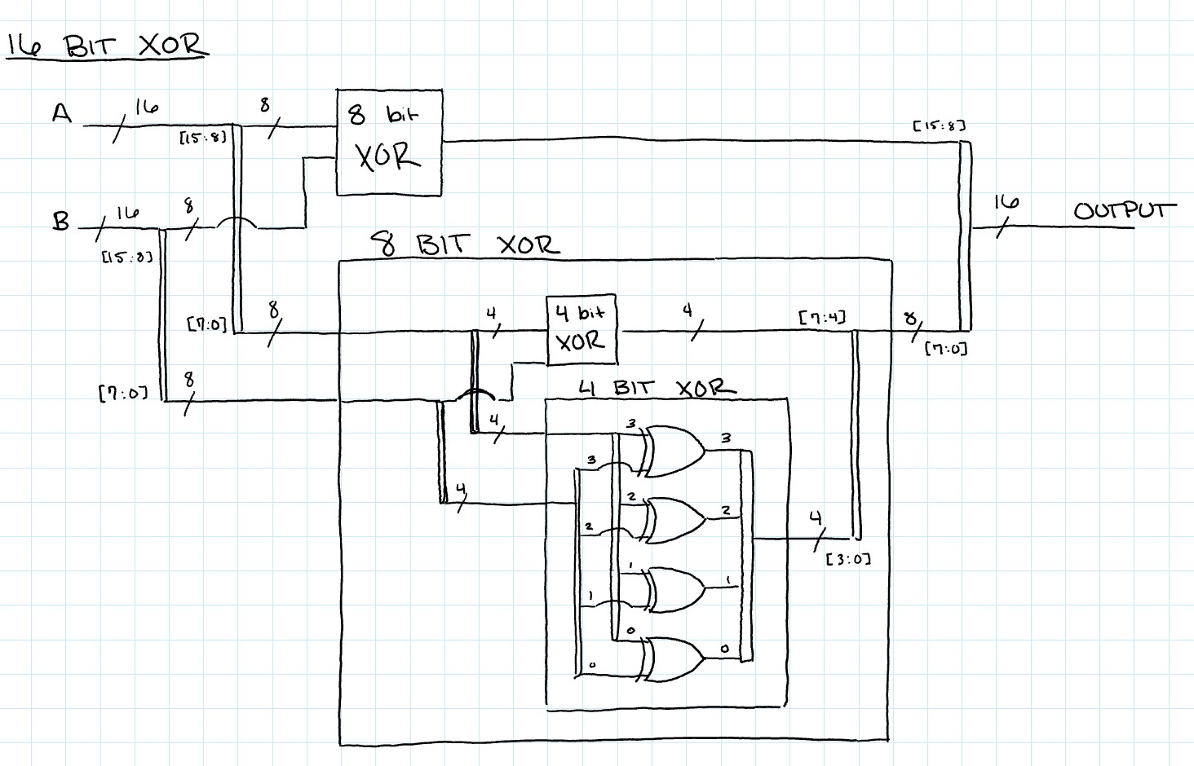

16 Bit XOR Gate

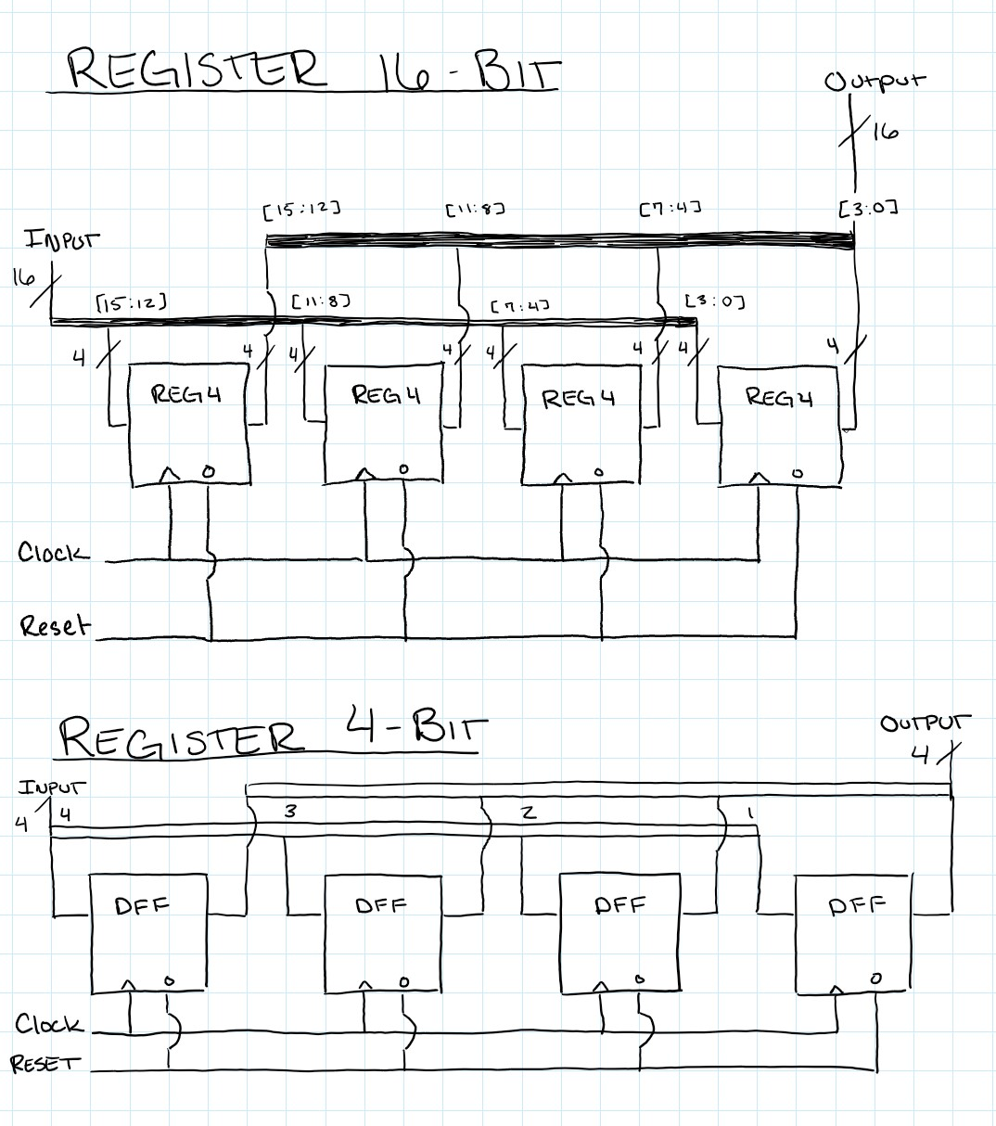

16 Bit and 4 Bit Register

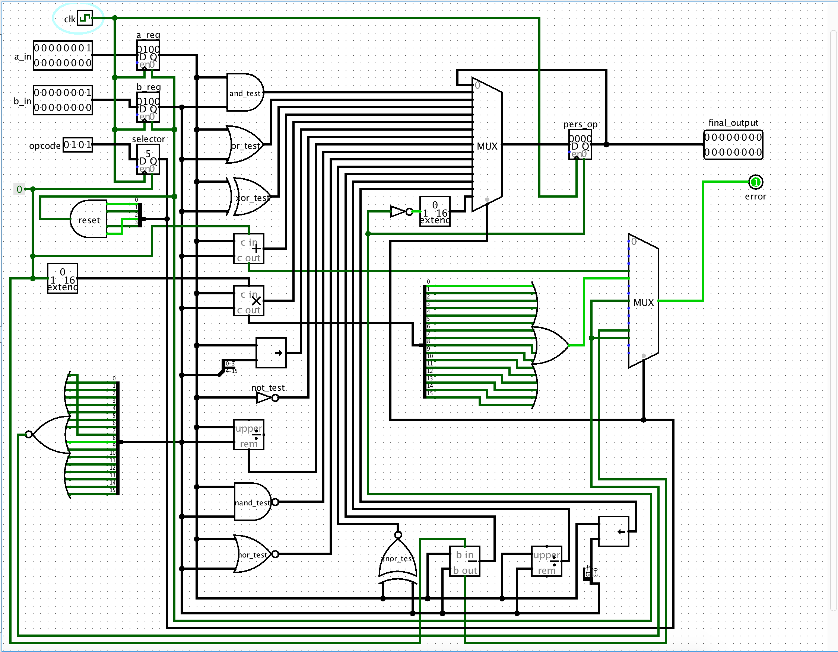

Complete ALU Diagram

**State Machine Components**

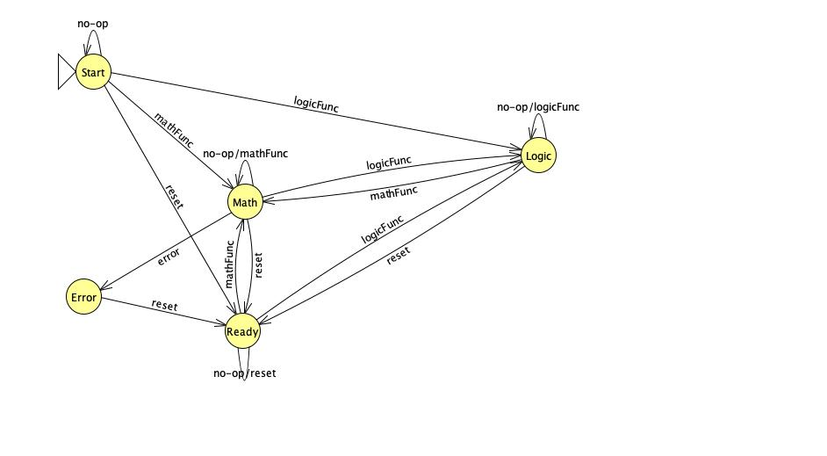

ALU State Machine

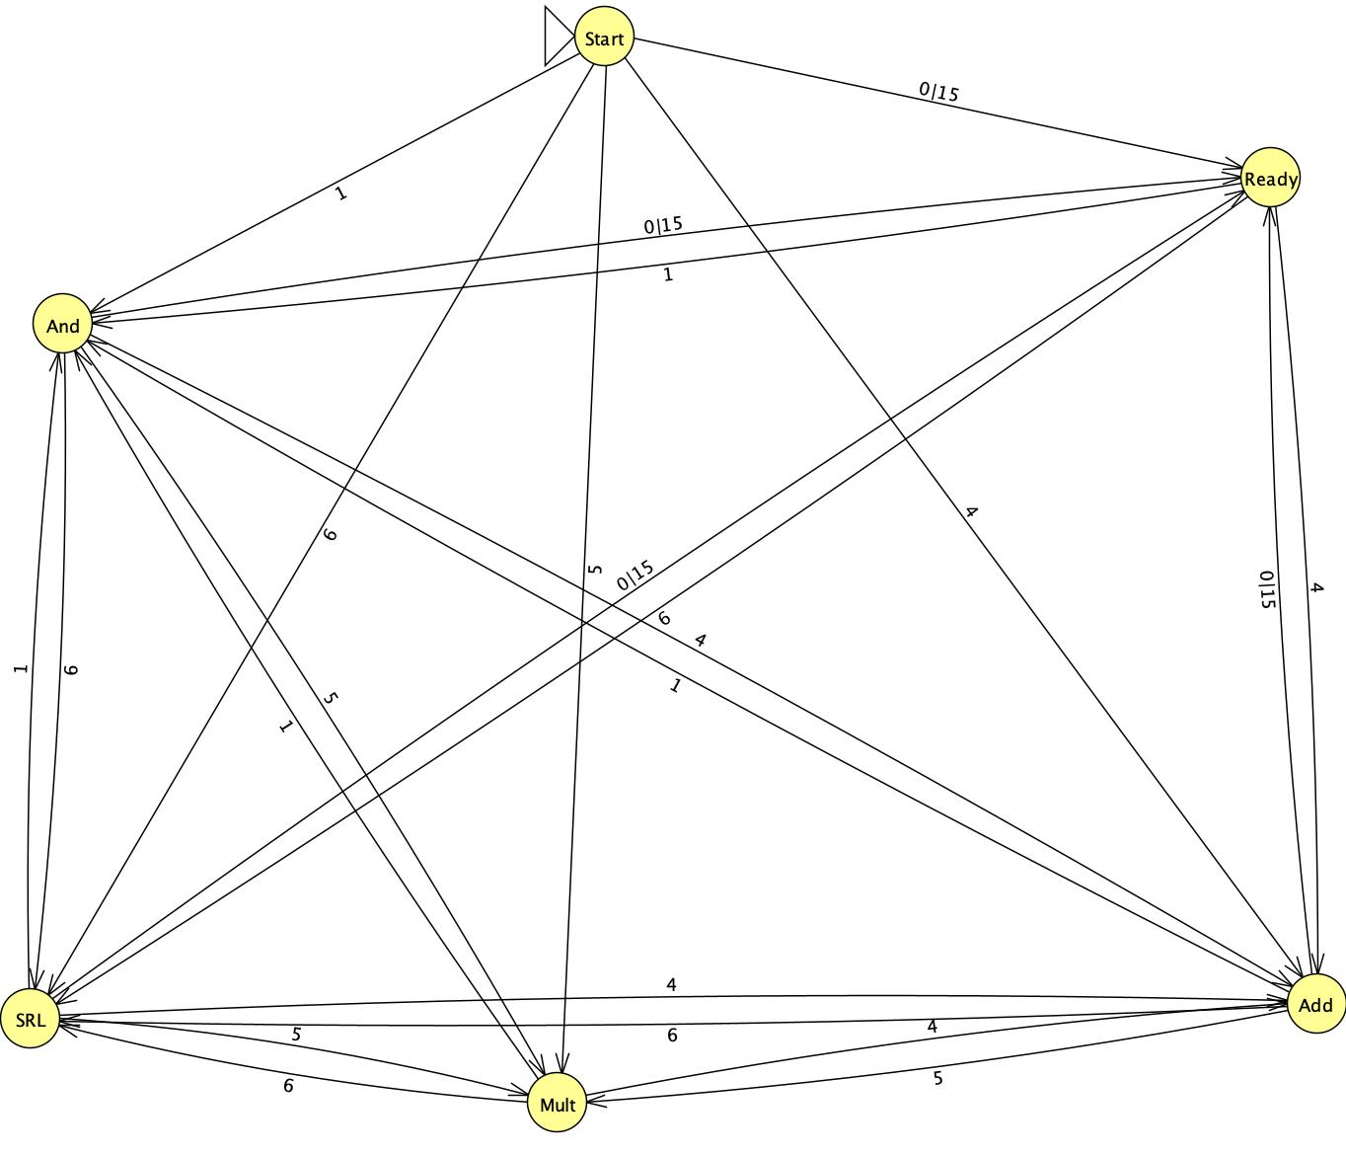

State Machine of ALU Components

**Opcode:**

0 > 0000 No Op  
1 > 0001 AND  
2 > 0010 OR  
3 > 0011 XOR  
4 > 0100 ADD  
5 > 0101 MULTIPLY  
6 > 0110 Shift Right 7 > 0111 NOT  
8 > 1000 MOD

9 > 1001 NAND

10 > 1010 NOR

11 > 1011 XNOR

12 > 1100 SUBRACT

13 > 1101 DIVIDE

14 > 1110 Shift Left

15 > 1111 Reset